Universidade do Algarve
  - Faculdade de Ciências e Tecnologia
  - Licenciatura em Engenharia Informática

Redes de Computadores I

Laboratório 3
Wireshark - DNS

Realizado por: Diogo Carvalho nº 90247
PL: 2
Docente: Rui Filipe Rosa Paulo
Ano Letivo: 2025/2026

Relatório

1. nslookup

- Run nslookup to obtain the IP address of the web server for the Indian Institute of Technology in Bombay, India: www.iitb.ac.in. What is the IP address of www.iitb.ac.in
R: O IP address de www.iitb.ac.in é 103.21.124.133.

- What is the IP address of the DNS server that provided the answer to your nslookup command in question 1 above?
R: O IP address que providenciou a minha resposta à pergunta anterior foi 10.255.255.254 e a Porta é 53.

- Did the answer to your nslookup command in question 1 above come from an authoritative or non-authoritative server?
R: As respostas vieram de um Non-authoritative server.

- Use the nslookup command to determine the name of the authoritative name server for the iit.ac.in domain. What is that name? (If there are more than one authoritative servers, what is the name of the first authoritative server returned by nslookup)? If you had to find the IP address of that authoritative name server, how would you do so?
R: Apareceram 3 servidores no dominio iit.ac.in o nome do primeiro é dns3.iitb.ac.in., utilizava o comando “nslookup dns1.iitb.ac.in” para encontrar o IP adress que neste caso é 103.21.125.129.

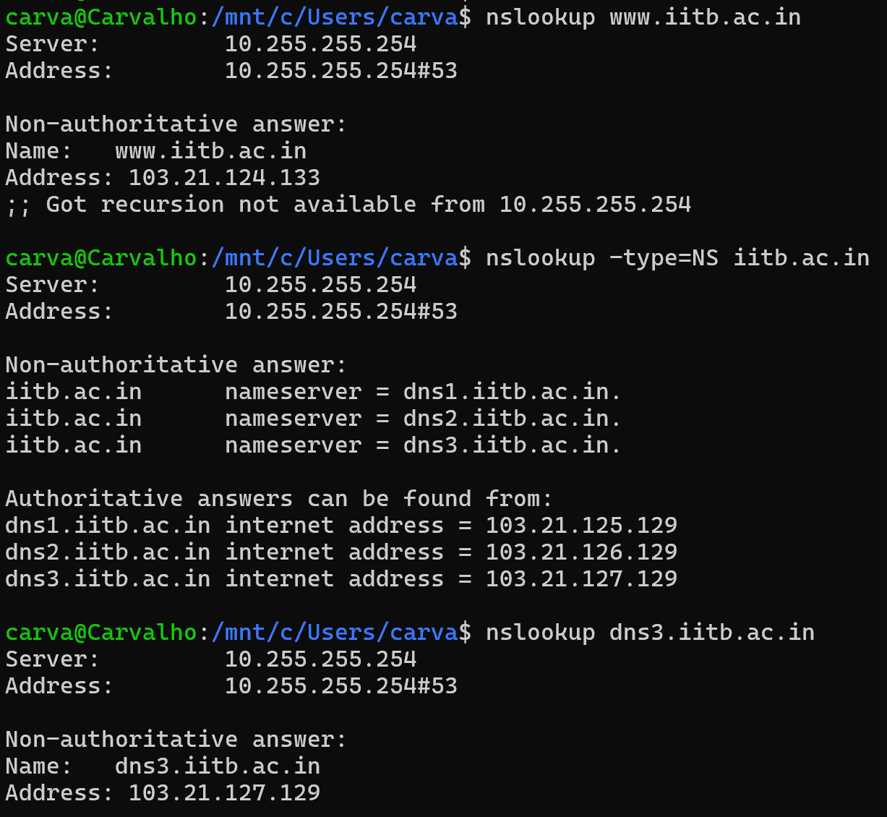

2. The DNS cache on your computer
Para limpar a DNS cache basta utilizar:
No Mac – “sudo killall -HUP mDNSResponder”
No Windows – “ipconfig /flushdns”
No Linux – “sudo systemd-resolve --flush-caches”
No Ubuntu(v22.04 and later) – “sudo resolvectl flush-caches”

3. Tracing DNS with Wireshark
(ip.addr == 10.20.83.138)
- Locate the first DNS query message resolving the name gaia.cs.umass.edu. What is the packet number in the trace for the DNS query message? Is this query message sent over UDP or TCP?
R: É o pacote numero 445, e foi enviado por UDP.
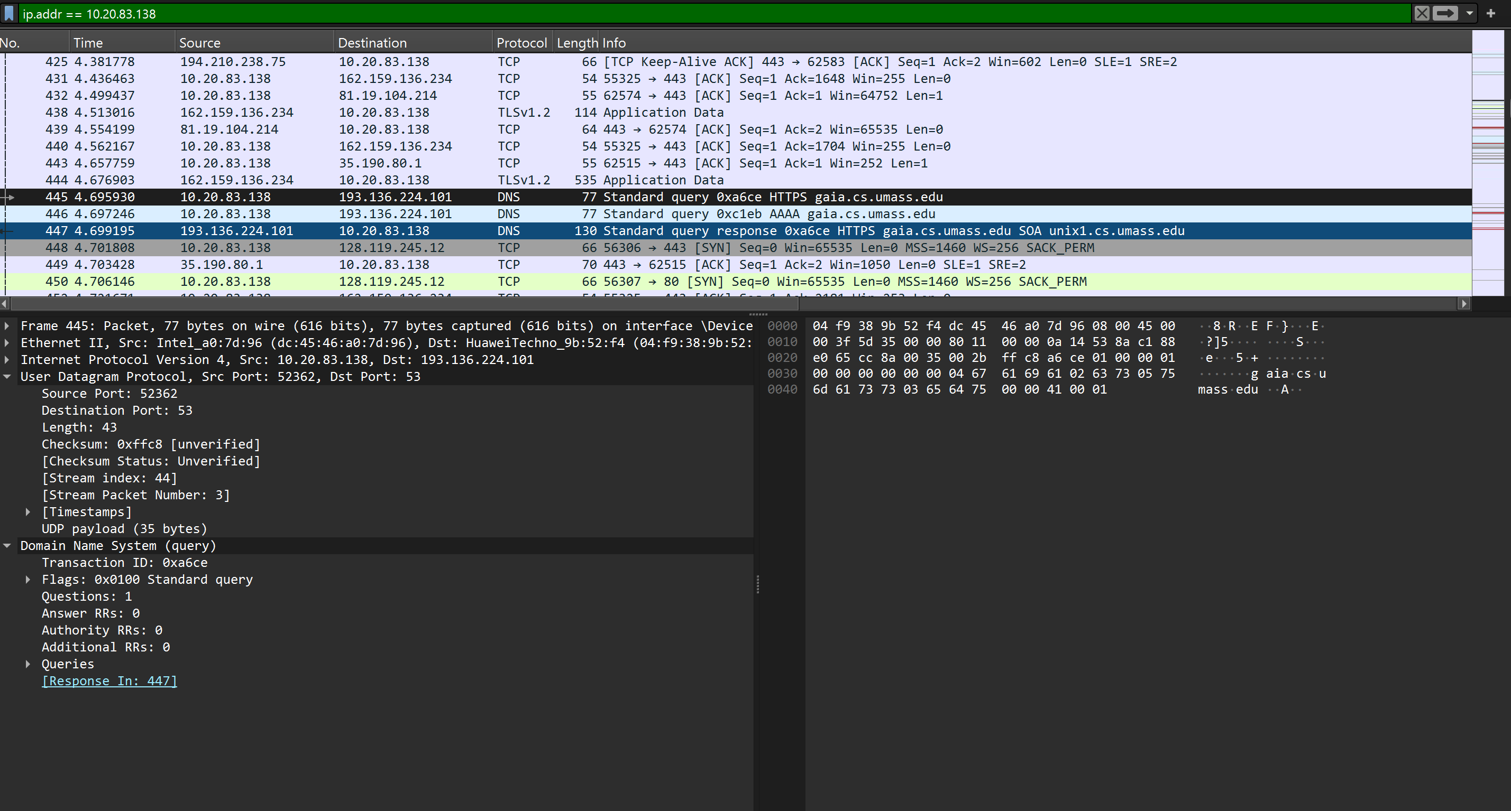

- Now locate the corresponding DNS response to the initial DNS query. What is the packet number in the trace for the DNS response message? Is this response message received via UDP or TCP?
R: O numero do pacote foi o 447, a mensagem foi recebida por UDP.
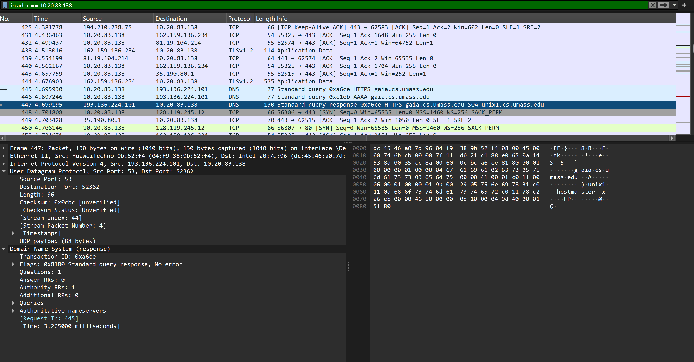

- What is the destination port for the DNS query message? What is the source port of the DNS response message?
R: A porta destino é 53, e a porta origem é 53.

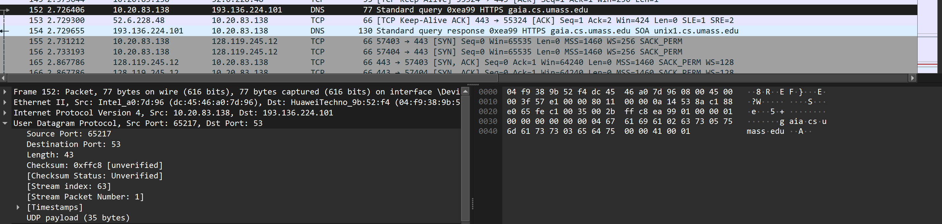

- To what IP address is the DNS query message sent?
R: A query foi enviada para o IP address 193.136.224.101.

- Examine the DNS query message. How many “questions” does this DNS message contain? How many “answers” answers does it contain?
R: A DNS query message, contem 1 pergunta e 0 respostas.
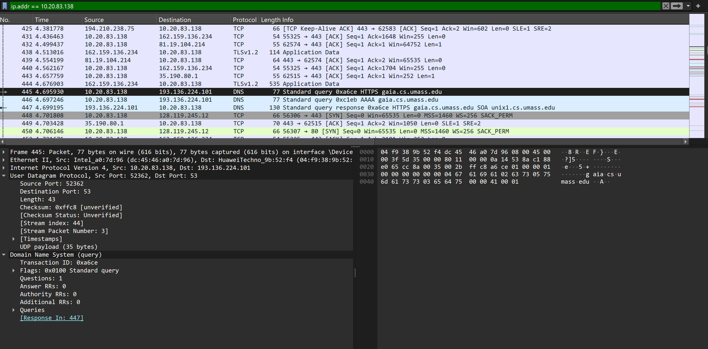
- Examine the DNS response message to the initial query message. How many “questions” does this DNS message contain? How many “answers” answers does it contain?
R: A mensagem de resposta do DNS à query inicial, contem 1 pergunta e 0 respostas.

- The web page for the base file http://gaia.cs.umass.edu/kurose_ross/ references the image object http://gaia.cs.umass.edu/kurose_ross/header_graphic_book_8E_2.jpg , which, like the base webpage, is on gaia.cs.umass.edu. What is the packet number in the trace for the initial HTTP GET request for the base file http://gaia.cs.umass.edu/kurose_ross/? What is the packet number in the trace of the DNS query made to resolve gaia.cs.umass.edu so that this initial HTTP request can be sent to the gaia.cs.umass.edu IP address? What is the packet number in the trace of the received DNS response? What is the packet number in the trace for the HTTP GET request for the image object http://gaia.cs.umass.edu/kurose_ross/header_graphic_book_8E2.jpg? What is the packet number in the DNS query made to resolve gaia.cs.umass.edu so that this second HTTP request can be sent to the gaia.cs.umass.edu IP address? Discuss how DNS caching affects the answer to this last question.
R: O pacote do HTTP GET é 462, O pacote do DNS inicial é 445 e o pacote da resposta é 447, O pacote com o HTTP GET da imagem não aparece no trace porque o servidor redireciona o acesso para HTTPS. A partir daí, o pedido da imagem é feito sobre TLS e fica cifrado, logo o Wireshark não mostra o “HTTP GET …jpg” em claro.

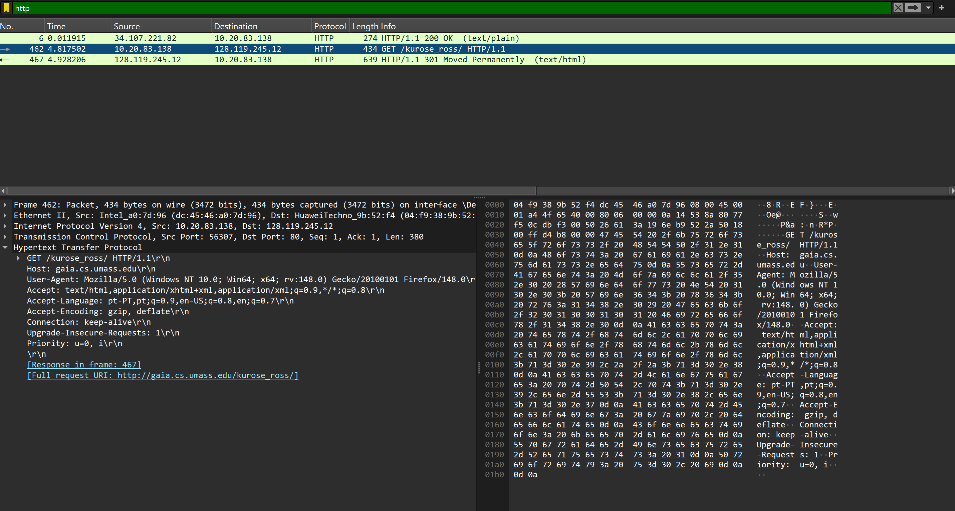

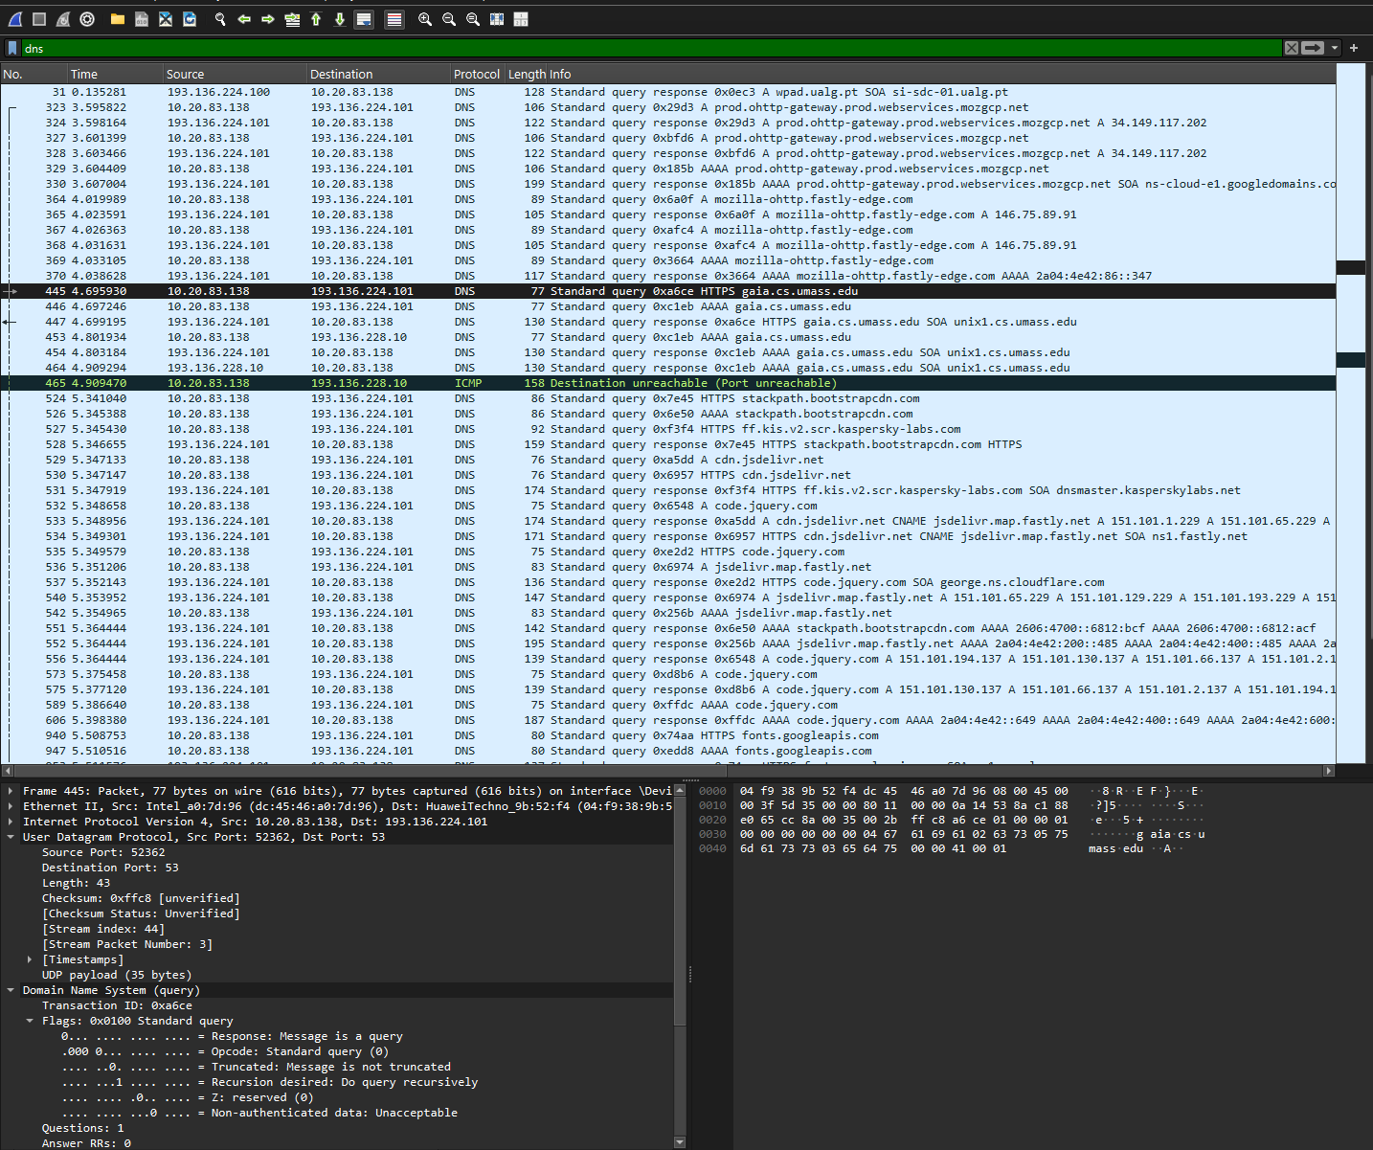

Executando – “nslookup www.cs.umass.edu”
- What is the destination port for the DNS query message? What is the source port of the DNS response message?
R: A porta de destino da mensagem query DNS é 53, e a porta de origem da resposta a mensagem query DNS é 53.
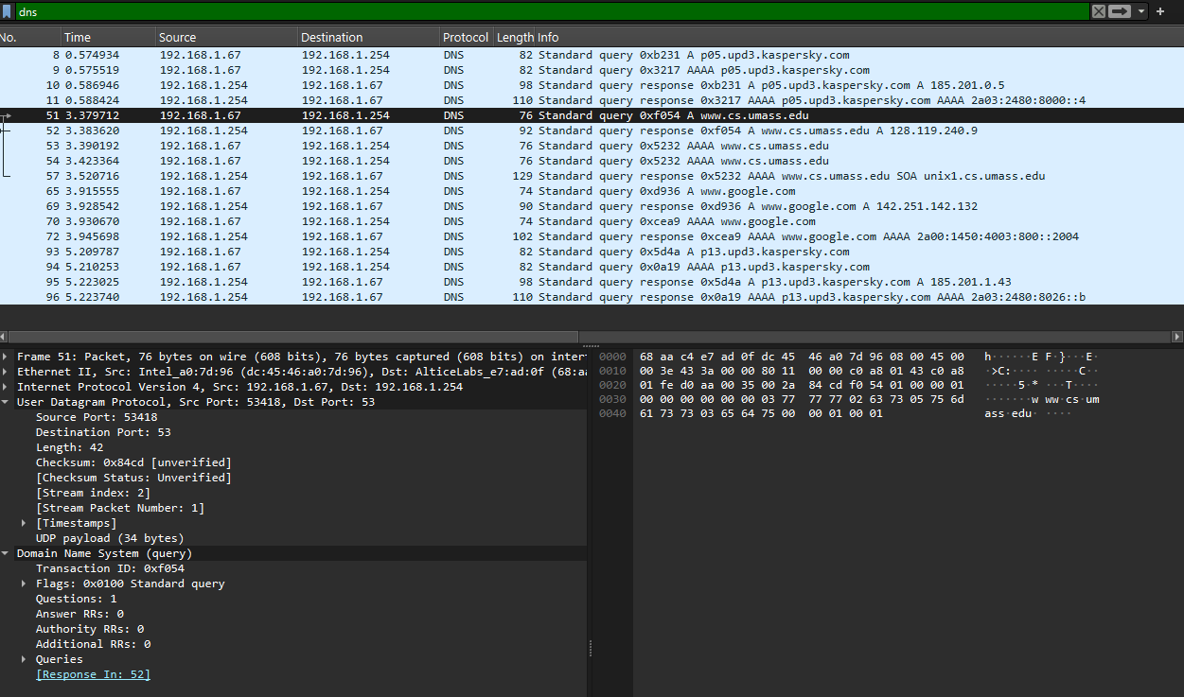
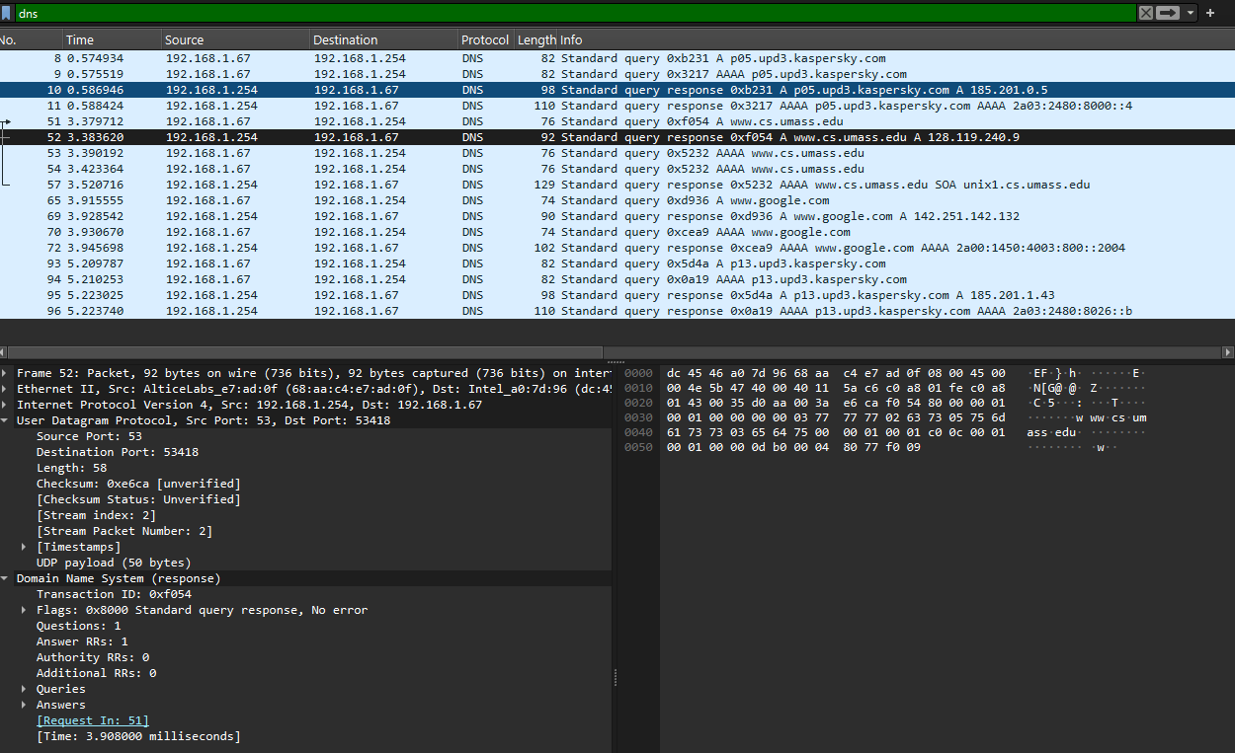
- To what IP address is the DNS query message sent? Is this the IP address of your default local DNS server?
R: A mensagem query DNS foi enviada para o IP address 193.136.224.101, sim este IP address é o default.

- Examine the DNS query message. What “Type” of DNS query is it? Does the query message contain any “answers”?
R: A query DNS é Type A, e não contem nenhuma pergunta.

Executando – “nslookup –type=NS umass.edu”

- Examine the DNS response message to the query message. How many “questions” does this DNS response message contain? How many “answers”?
R: A DNS query message, contem 1 pergunta e 4 respostas. 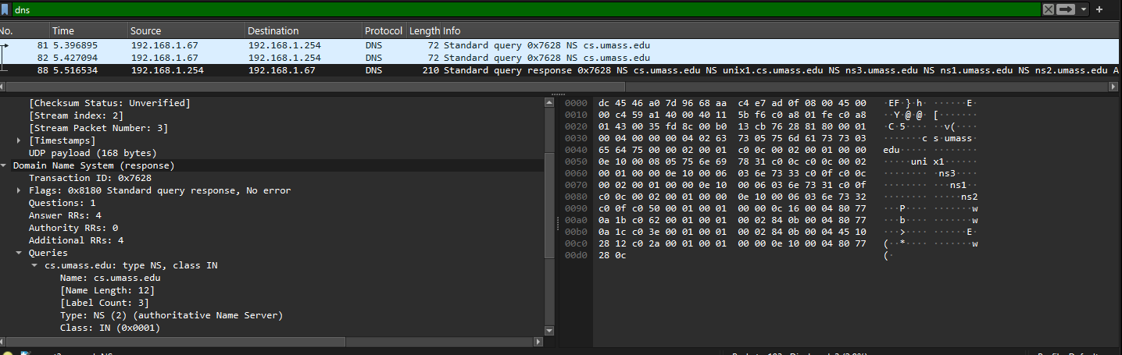

- To what IP address is the DNS query message sent? Is this the IP address of your default local DNS server?
R: A mensagem query DNS foi enviada para o IP address 192.168.1.254, sim este IP address é o default.

- Examine the DNS query message. How many questions does the query have? Does the query message contain any “answers”?
R: A DNS query message, contem 1 pergunta e 0 respostas.
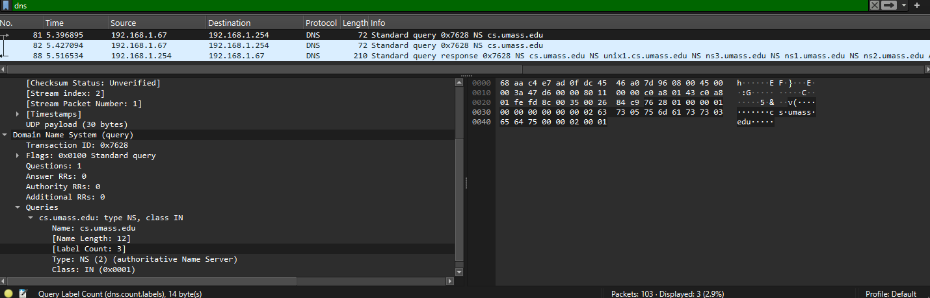
- Examine the DNS response message (in particular the DNS response message that has type “NS”). How many answers does the response have? What information is contained in the answers? How many additional resource records are returned? What additional information is included in these additional resource records (if additional information is returned)?
R: A DNS query message, contem 4 respostas,
A informaçao contida nas respostas é:
unix1.cs.umass.edu,
ns3.umass.edu,
ns1.umass.edu,
ns2.umass.edu;
Foram returnados 4 registros de recursos adicionais, com a informaçao seguinte:
ns1.umass.edu → 128.119.10.27
ns2.umass.edu → 128.119.10.28
ns3.umass.edu → 69.16.40.18
unix1.cs.umass.edu → 128.119.40.12
